|  |  |  |  |  |  |
| --- | --- | --- | --- | --- | --- |
| Date | 23-Sep-22 | | | Tester Name | Andrew McLaughlin |
| Environment | Penfax - Test | | | Login used |  |
| Operating System | Windows | Version: | Update: | | |
| Software Used | Edge | Version: | Update: | | |
| Select Software | Version: | Update: | | |
| Release version |  | | | | |
| Title | M46.07 Payroll run for month of indexing included indexing | | | | |
| Test Type | Regression | | | | |
| Test Scenario | M46.07 Payroll run for month of indexing included indexing | | | | |
|  |  | | | | |
| Expected Results |  | | | | |
| Pass/Fail | Pass | | | JIRA# | N/A |

Describe your steps with screenshots:

Run pre-indexing query for a small plan like ATLS – **Query Available on Page 3 here**: H:\Quality Assurance\Prod Apps\PenfaxV5\MEPP\Procedures\How to Run Indexing in Penfax 5.docx

Apply indexation rate for ATLS with benefits commencing 01-JAN-1900, effective date the day you want them to start, for **every Recipient Type**. 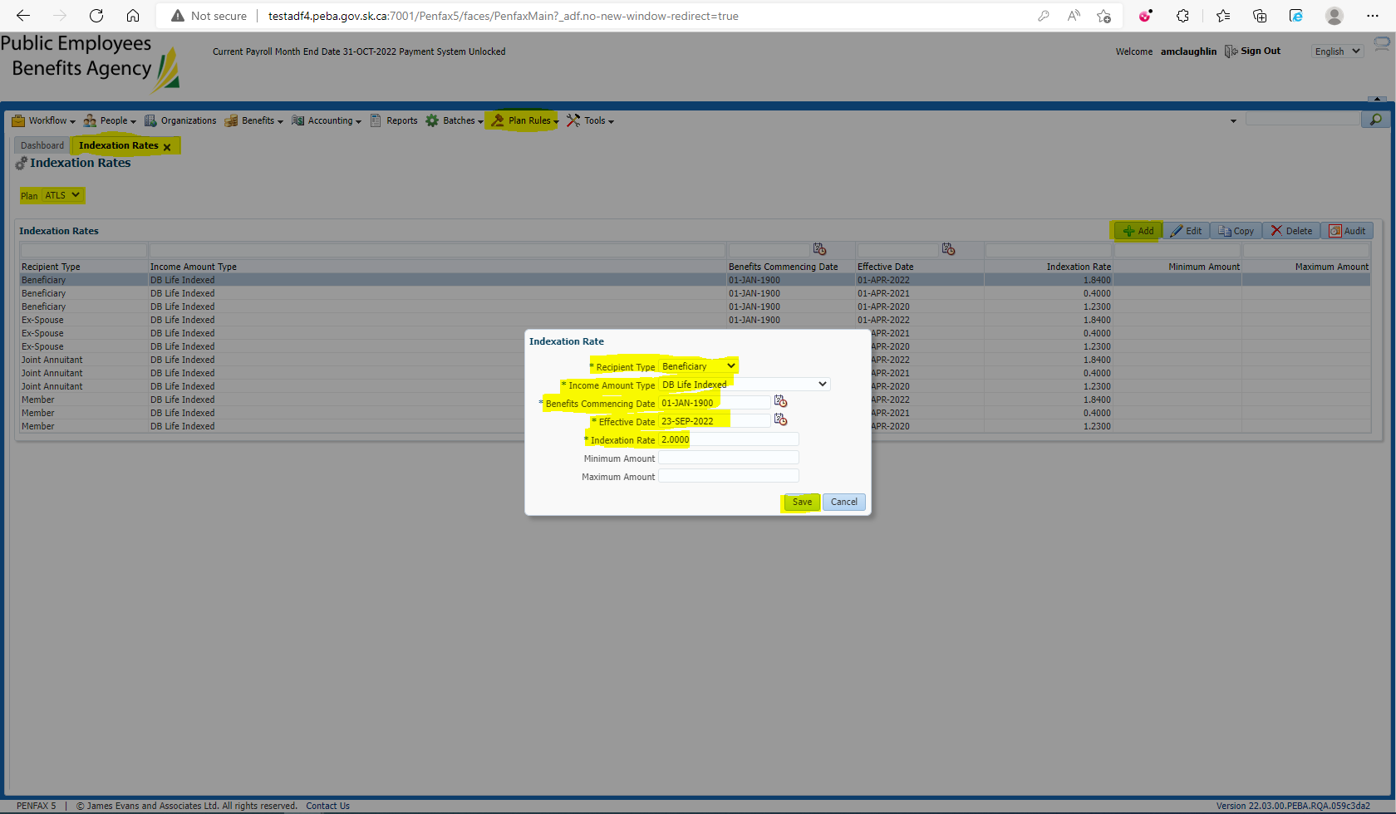

Run post indexing query for ATLS **Query Available on Page 5 here**: H:\Quality Assurance\Prod Apps\PenfaxV5\MEPP\Procedures\How to Run Indexing in Penfax 5.docx

Run the Indexation Batch for the Plan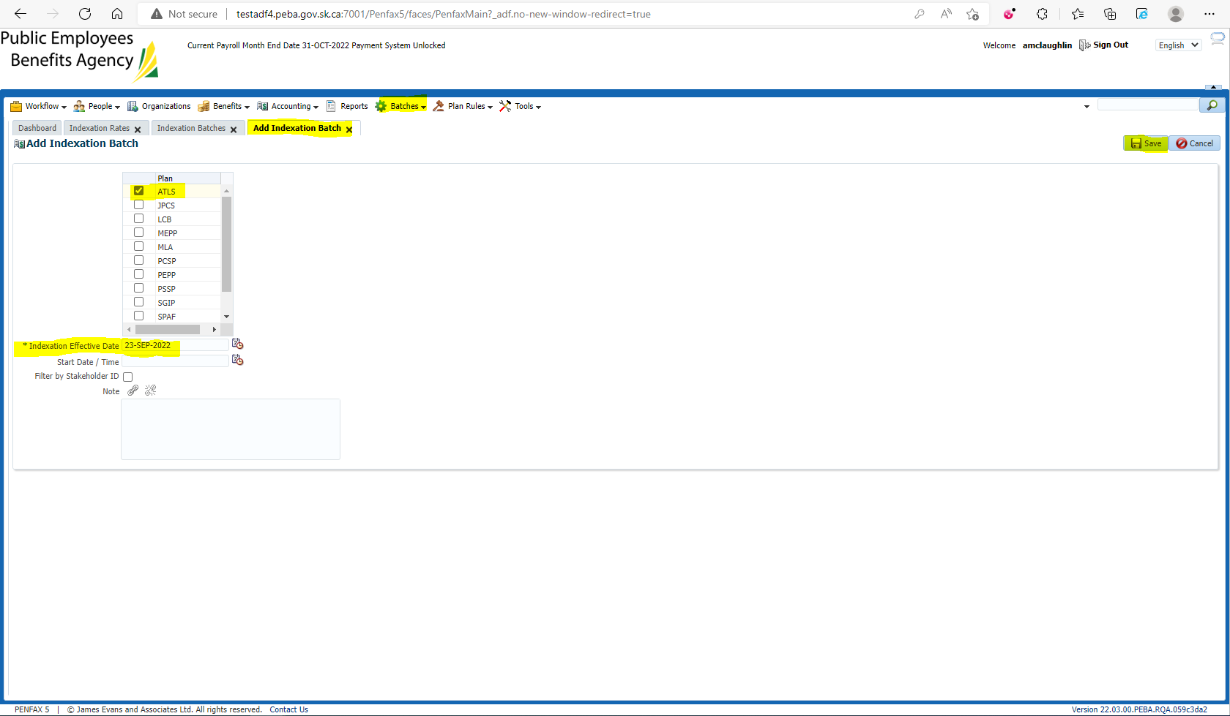

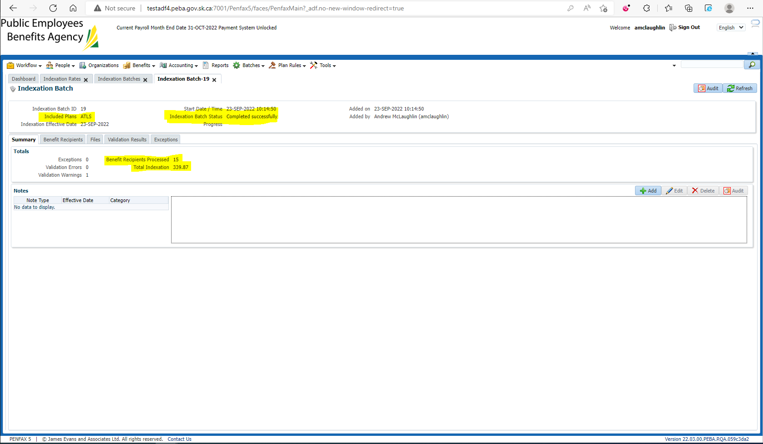

Compare the amounts b/w pre and post indexing query results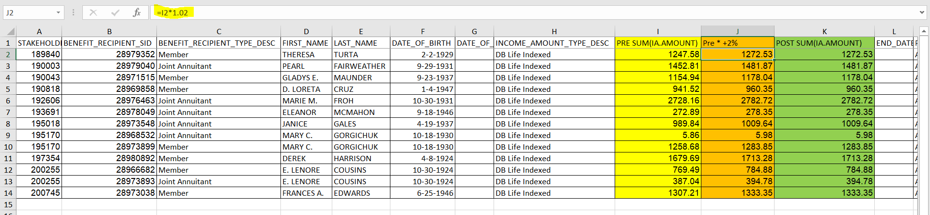

Verify post indexing increase is applied in the payment production batch

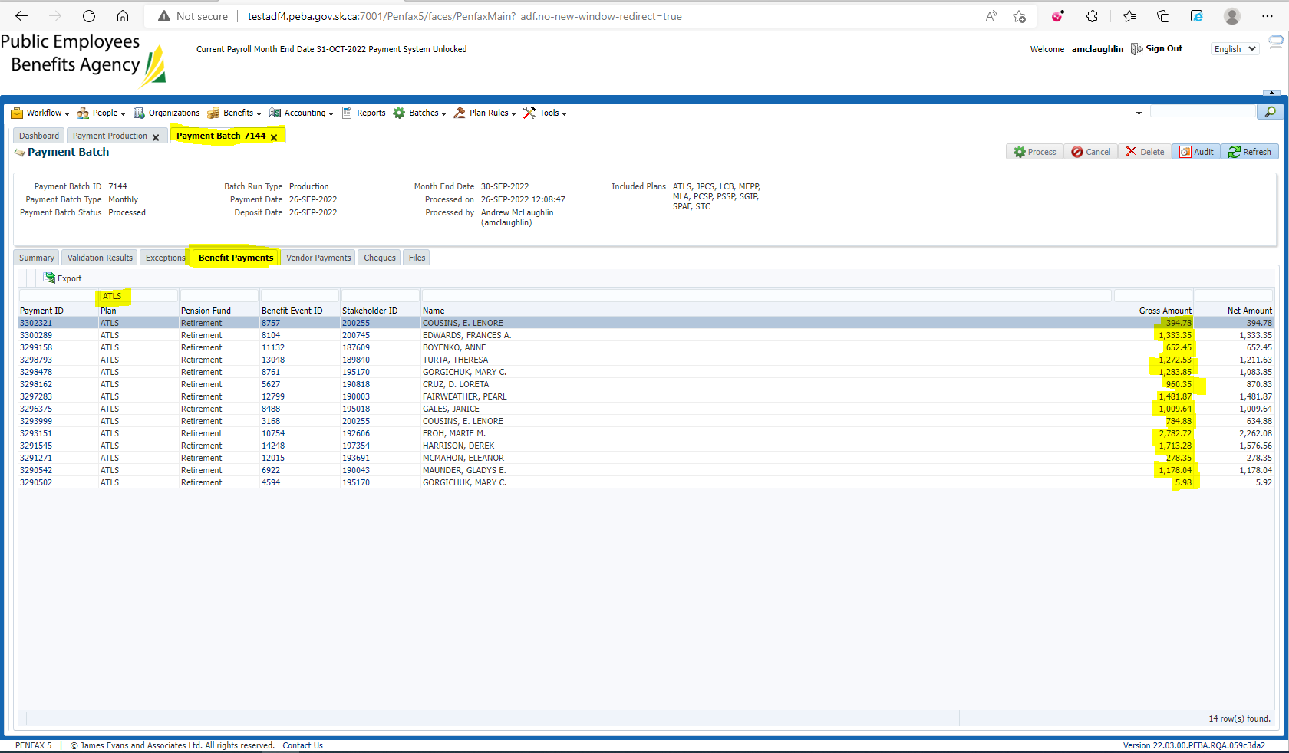

SID 200255 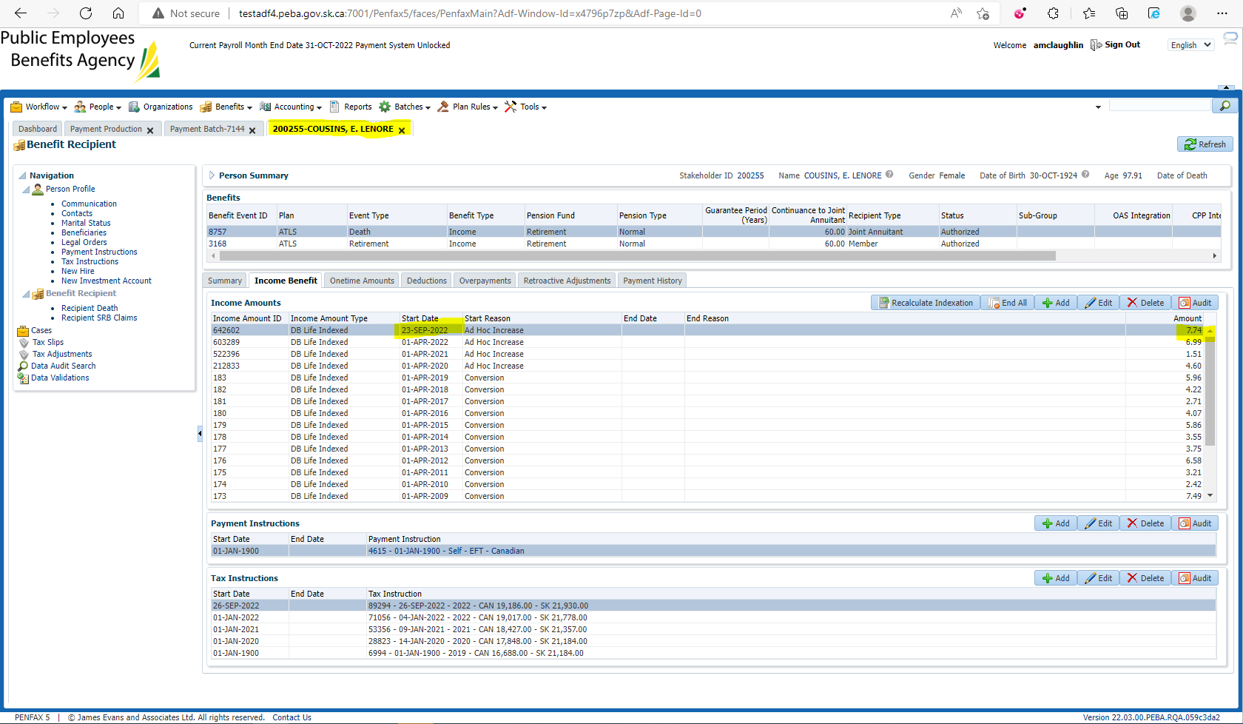

September payment vs August Payment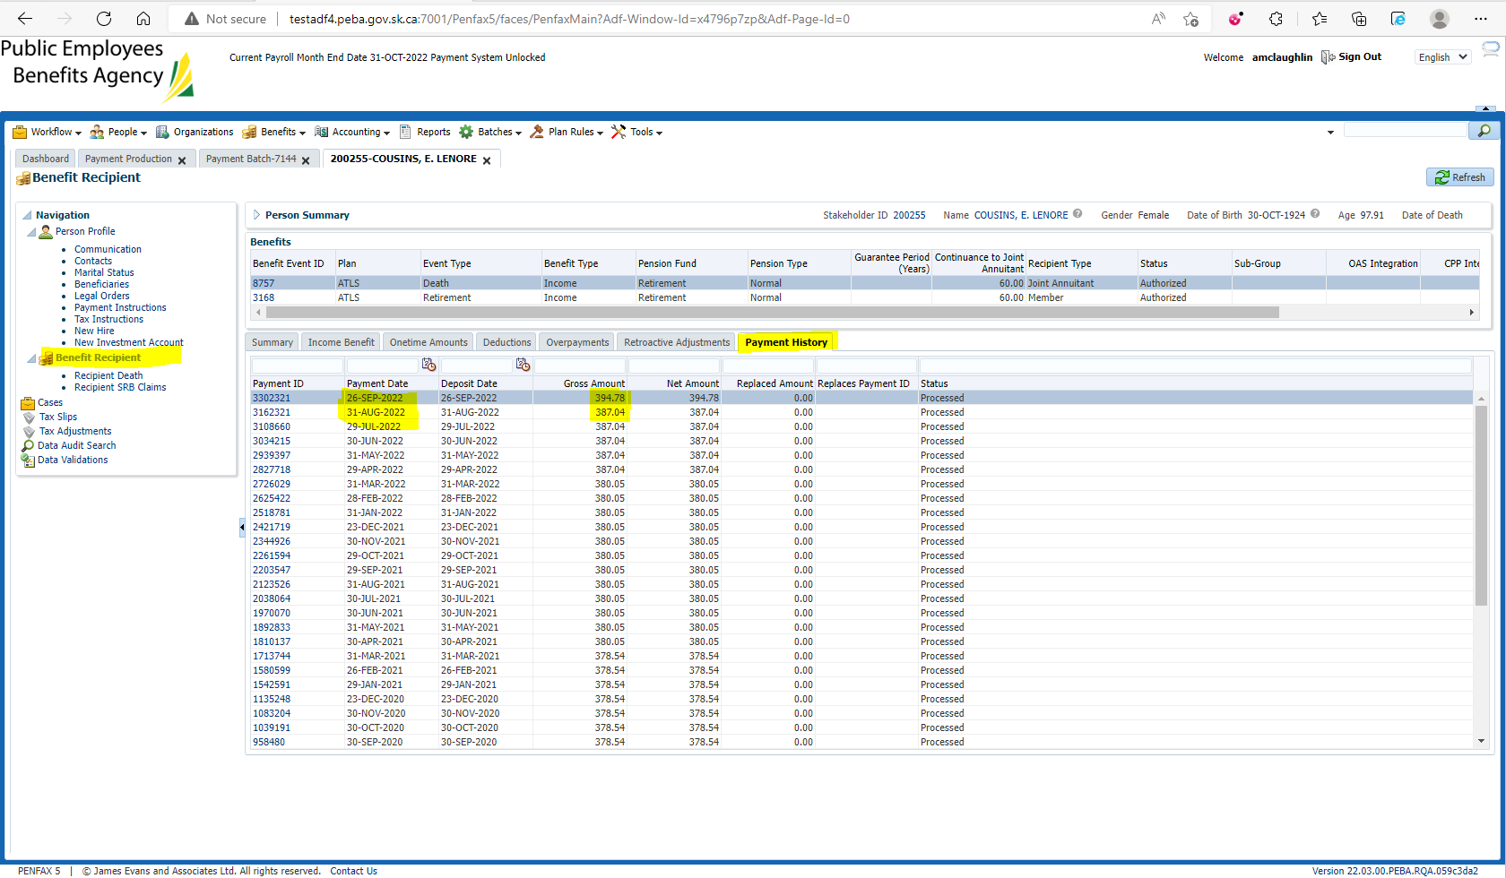

$394.78 - $387.04 = $7.74

Matches the increase